Introduction to Programming
with Scientific Applications
(Spring 2025)
Final project
Study ID | Name | % contributed
202306248 | Asger Konradi Lauridsen | 50%
202307147 | Alexander Kjær Bang Olsen | 50%
max 3 students
Briefly state the contributions of each of the group members to the project
Underneath we’ve stated which member has produced the base code for each function, we’ve worked sitting beside each other discussing whichever hurdle came up and helping each other make code clearer, and simpler.
Meaning that the code has been reviewed and changed so many times that its mostly more of a collaborative effort all around
Asger: get_prices, stock_plot
Alexander: portfolio_weights, minimum_variance_portfolio
Together: investment_details, return_distributions_plot, return_distributions_multiplot
Report has been written in collaboration
Declaration on Generative Artificial Intelligence (see https://studerende.au.dk/en/gai)
No AI has been used in the production of the project

Note on plagiarism
Since the evaluation of the project report and code will be part of the final grade in the course, plagiarism in your project handin will be considered cheating at the exam. Whenever adopting code or text from elsewhere you must state this and give a reference/link to your source. It is perfectly fine to search information and adopt partial solutions from the internet – actually, this is encouraged – but always state your source in your handin. Also discussing your problems with your project with other students is perfectly fine, but remember each group should handin their own solution. If you are in doubt if you solution will be very similar to another group because you discussed the details, please put a remark that you have discussed your solution with other groups. For more Aarhus University information on plagiarism, please visit http://library.au.dk/en/students/plagiarism/.

Project - Portfolio
Code walkthrough and structure
Our project consists of 7 functions, serving different purposes for the tasks in our code. We have implemented it such that our functions can be reused with different parameters as long as the parameters uphold the requirements.

We have some inputs that the program requires to give a meaningful result.
- A period (start_date, end_date) on the format “month/day/year”
- Tickers of stocks in a list. Example: ["IBM.US","GOOGL","AAPL","MSFT","NFLX","NVO.US","10YUSY.B"]
- Step size in format “d”, “daily”, ”w”, “weekly”, “m”, “monthly”, “q”, “quarterly”, “y”, “yearly”, or a natural number: 1, 5, 21, 63, 252
- Gammas as a list (A risk factor)

get_prices: The first function we have requires the 3 first of the outside inputs. In the function we use pandas_datareader to access Stooq daily for stock data. transforming the data to return the prices as a list of np.array’s and the time indexes, checking inputs via assertions, filling missing values and removing unwanted data along the way.

stock_plot: this function takes inputs: prices, index and tickers
A simple function that plots the prices of the different stocks over time using matplotlib with legends to identify each stock.

get_investment_details: this function takes the list of vectors “prices” it uses the features of the numpy.array class to calculate a matrix of returns from this matrix we calculate average return “mu”, the Covariance matrix “sigma” and a vector “sigma_s” giving the variance of the stocks.

return_distribution_plot: This function takes the list of variances “sigma_s”, average return vector “mu”, the list of stocks/portfolios “tickers” and the title of the plot. This function plots the return distribution of different stocks/portfolios assuming normality. We plot the distributions of the returns in the interval $\left[-3·σ_{max},3·σ_{max}\right]$ to capture most of the tails.

return_distribution_multiplot:
Mostly a copy of the return_distribution_plot but plotted on different plots to make it easier to wrap your head around.

portfolio_weights:
This function takes the inputs: the average return vector “mu”, the covariance matrix “Sigma” and the outside input of wanted gammas. This function first defines a wrapper for the objective function specifying parameters (specifically gamma) which we want to maximize under.
Then it solves the minimization problem minimizing -obj for every lambda using scipy.optimize.minimize returning the optimal portfolios, their expected returns and standard deviations (also a dataframe for visualisation).

minimum_variance_portfolio:
takes the covariance matrix Sigma and computes the minimum variance portfolio which is the portfolio with the lowest amount of variance in this setting.

Modules used
Pandas and Numpy are just to make life easier. It’s easy to handle data when you have those modules.
Pandas_datareader is the most essential for our program, as otherwise we wouldn’t have any data. We tried different data readers but started and ended with pandas_datareader as it simply worked without much issue.
Stooq, we used as our data broker, simply because it was what seemed to work the best and was easy to implement.
Matplotlib for plotting, simply because it’s a nice package and we’ve used it in class.
Scipy.stats.norm, we used to make our distributions for both the individual stocks and our portfolios, we used this specific package because one of us had used it before in a personal project.
scipy.optimize we used to solve our maximization problem, for the different gammas.
We've decided to specifically use this package because we’ve covered the implementation in class.
math.ceil we used to round up for the number of subplots we needed, one might choose to code it manually instead, we choose not to.

Choices made
We’ve made the choice to write the code functionally, because of the clarity in the code and the reusability of each function. This was important to us!

We chose early on to look only on the market is open, meaning not having to fill data for weekends and holidays. This might imply slightly higher volatility as the sum of weekend news will be acted on Monday, while also not having any noise on weekends means less volatility. As both approaches seem to have pros and cons, we choose the easier option.

When making sure that the period input is of the right type we tried to implement an assertion to make sure that there were actually market days in the period (otherwise the problem obviously doesn't work). we realized that our program would already throw us an error because there were no “open” data for the period to pull, we choose not to make an assertion to cover this edge case.

We’ve chosen to calculate the covariance matrix manually instead of using the numpy function, because the assignment told us to use the biased estimator:
$$Σ=\frac{1}{n}\sum_{i=1}^{n}{\left(r_{i}-μ\right){\left(r_{i}-μ\right)}^{T}}$$
Instead of
$$cov(R)=\frac{1}{n-1}\sum_{i=1}^{n}{\left(R_{i}-μ\right){\left(R_{i}-μ\right)}^{T}}$$
with $R=(R_{1},…,R_{m})$being the matrix of returns and $R_{j}$ being the vector of returns of each stock in period i.
in matrix notation this calculation becomes quite nice as
$$Σ=\frac{1}{n}\left(R-μ\right){\left(R-μ\right)}^{T}$$
With
$$μ=(μ,…,μ)$$

We chose to plot the PDF’s on the interval $[-3σ_{max},3σ_{max}]$ in extreme cases of high or low return this means that some of the tails will be cut off giving bad visualization, in the multiplot a way to solve this would be to adjust the center of the interval, but since this would make the graphs be less comparable we chose to stick with center at 0, accepting a little uglier graphs, in testing we only saw significantly “cut tails” with greater than yearly step_size.

Difficulties
One issue was with the get_prices function, when implementing the input step_size. the module we used lacked this feature, so we sliced the data manually having a “translator” dictionary to handle some string inputs.
Using Stooq we realized that we would sometimes have missing values in the datasets to combat this we used pandas to forward fill, this shouldn’t be too big of an issue having big datasets with few missing values.

This brings us to another issue, one we didn't quite solve. If the stock is delisted in the middle of the period, our program will FFILL the entire period meaning we end up having a period where the price is constant, which will make a lot of the calculations be off. This means that the user needs to make sure the stock hasn’t been delisted in the period.

Another problem we had was the solution with small step sizes. Because of small variance and covariances our solution came really close to our initial guess of $\frac{1}{n}$ with $n$ being our number of stocks we would optimize over. So, the optimization works best with monthly bigger step sizes, because of that we used quarterly in all of our graphs so it would be “nicer”.

Another issue we stumbled upon was when we made the functions: return_distribution_multiplot, return_distribution_plot work universally (in our 2 cases) the datatypes of our different inputs weren’t similar enough, specifically “mu” and “mu_p” weren't the same. We solved this by flattening and reshaping “mu” in different places solving the issue, maybe not the prettiest solution but quite easy to implement.

If we had to choose one thing that we regret not solving it would be the delisting issue. This could be done by making an assertion that enforced a max % of missing values for each stock in the period. Or making sure we could only have x periods in a row with missing data. The first would also put a cap on allowed % missing data in general.

Testing & Visualization
For the visualization we used 6 stocks and started with plotting the stock’s price development over our specified period (attachment 1). We then calculated and plotted the distributions of returns for the different stocks, in one plot (attachment 2) and in subplots (attachment 3).
With our solution we made a dataframe (Attachment 4) of an overview for our different gammas, where you can see the weights of different stocks. We also plotted the distribution of returns for our different gamma portfolios, here we saw what we expected: that an increase in gamma meant less tolerance for risk and thus a portfolio with lower volatility and lower return.

We did testing with making assertions in mind. Some examples would be start date being after end date, including a stock not listed at the beginning of the period or no market days being in the period specified. The 2 first issues we made assertions making sure the inputs were of the right type. The 3. we’ve discussed in “choices”.

When testing for higher values of gamma we saw that the portfolio seemed to be converging towards the minimum variance portfolio (seen in Attachment 8)(this is a concept from another course) so we made a function to find it such that we could confirm it and did so.

We’ve tried plenty of different stocks having done around 10 simultaneously still getting nice results and graphs, just a little harder to wrap your head around therefore we’ve decided to only have 6 in the graphs on this submission

Conclusion
To summarize, we created a program with 7 functions that values reusability and readability. We decided only to have stocks that were listed in the specified period and only used data where the market was open. If there were small gaps in the data, we forward filled it.

Our visualizations for the distribution of returns for the optimal portfolios under our gammas substantiated with higher gammas equals lower mean and standard deviation (risk). The scatter plot also showed in practice the theory about how the portfolio's weights would converge towards a minimum variance portfolio for higher gammas as calculated and visualized in attachment 8.

Attachment 1:
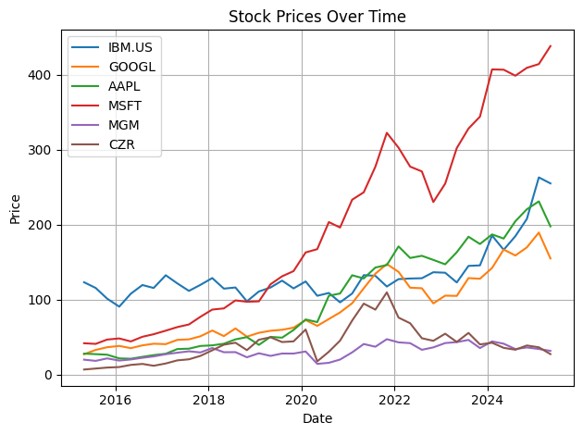
Attachment 2:
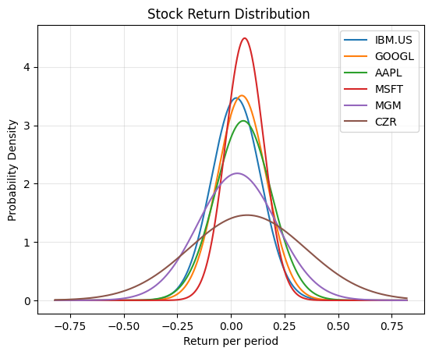

Attachment 3:
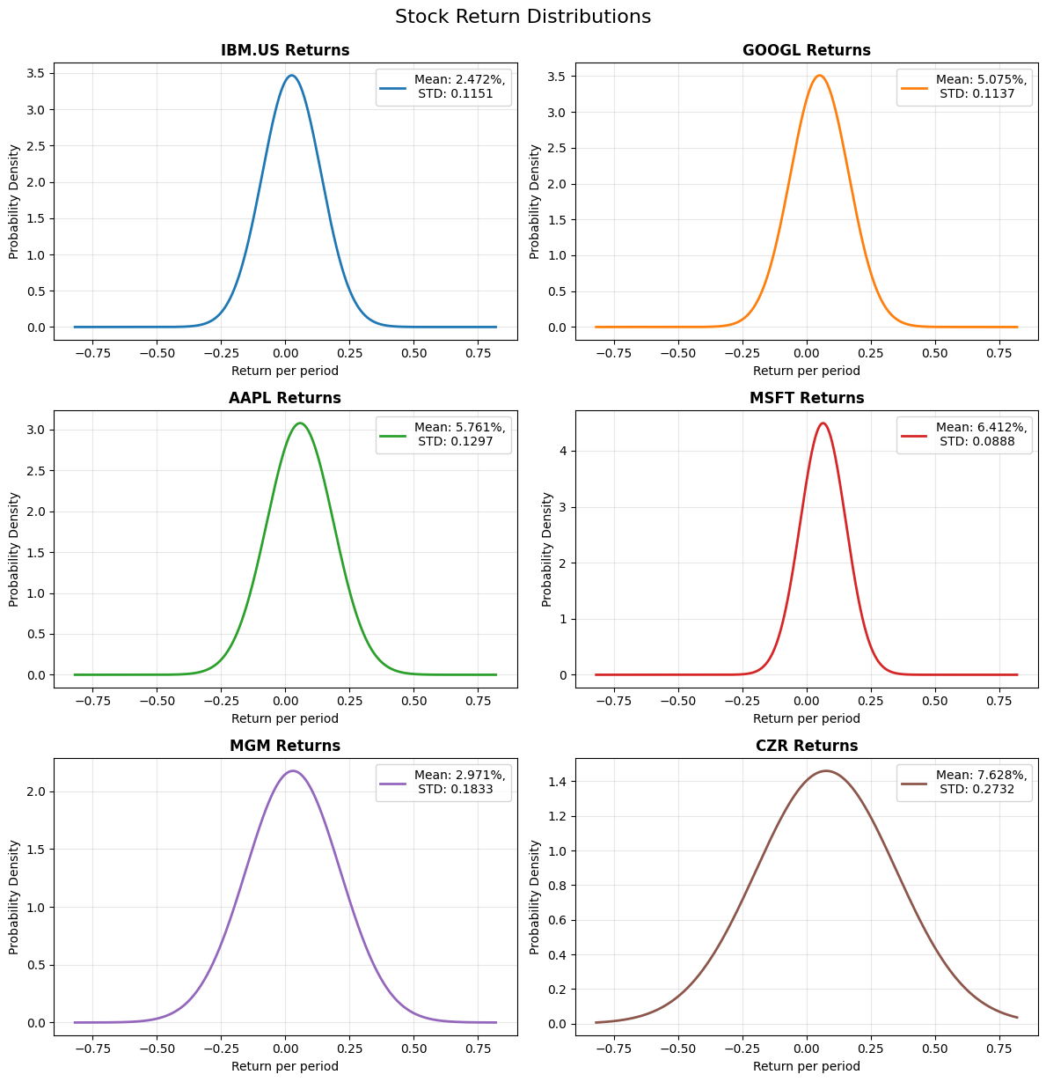

Attachment 4:
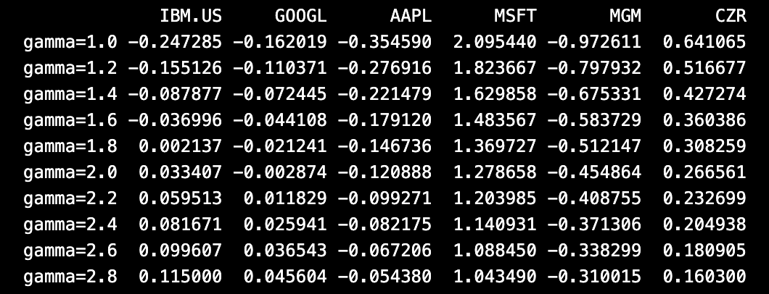

Attachment 5:
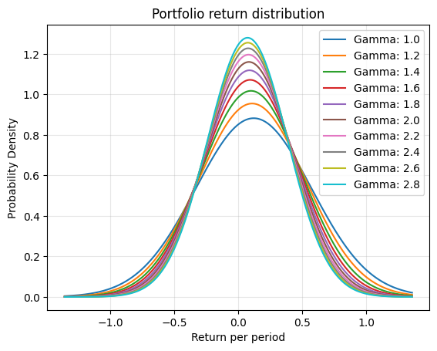

Attachment 6:
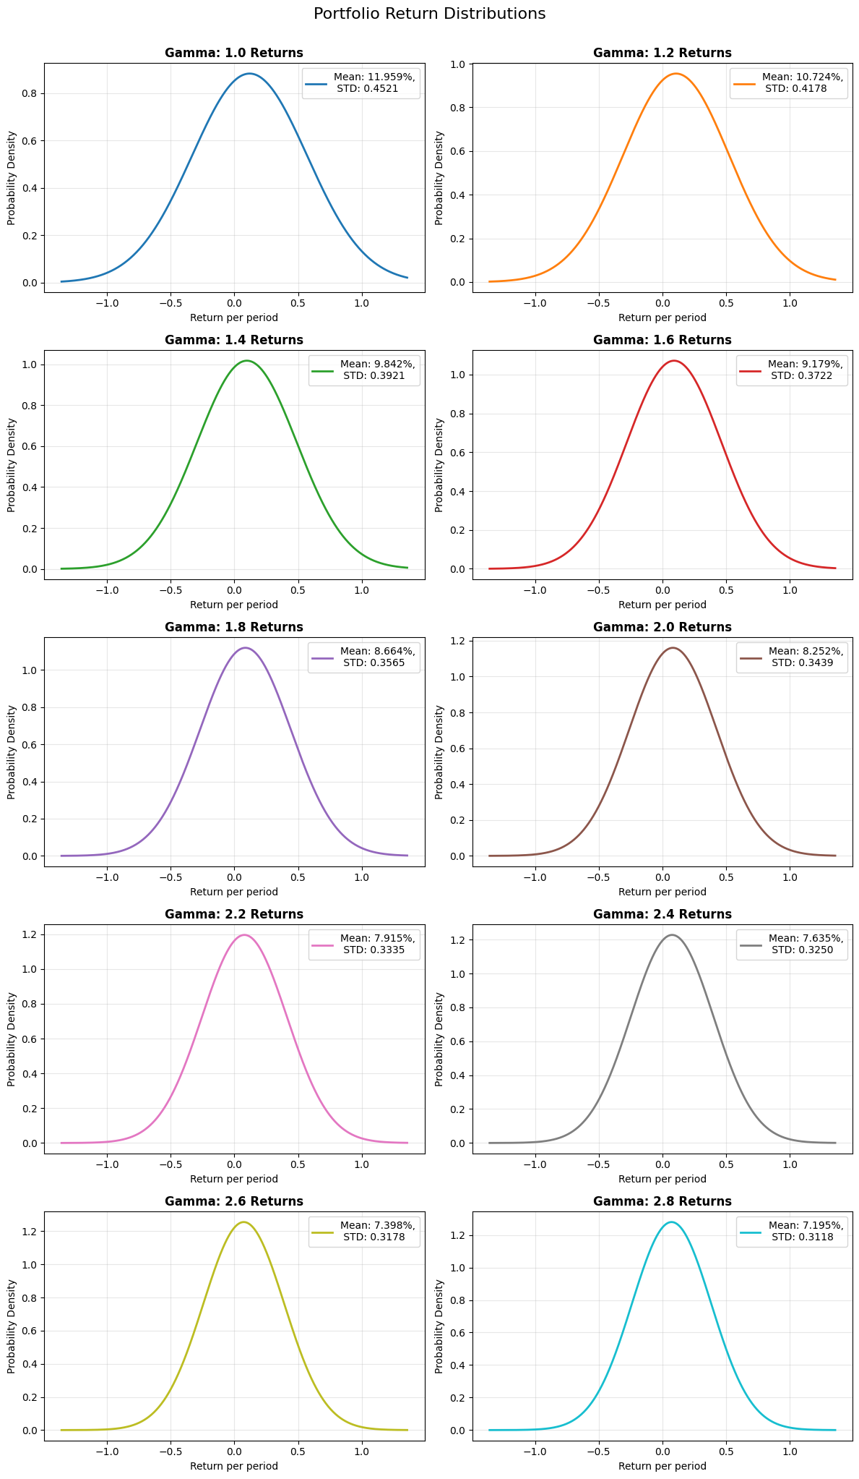

Attachment 7:
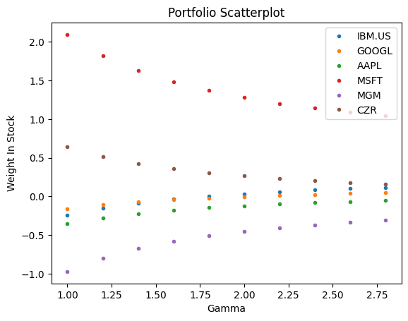
Attachment 8:
